Please use the Takeover Ad Book in the link below as a reference when creating your ad. Ads MUST be created using current templates located on Sotheby’s Design Vault. Do not duplicate existing ads that may have been created from a previous takeover and please be sure to adhere to the Sotheby’s Identity Standards Manual when creating your ads. Ads that are not submitted using the current templates will be rejected.
To access Design Vault:
Please log into Access.SIR.com. Go to the Apps & Tools and select the “New Design Vault” icon.
To create your ad:
In Design Vault go to the “Templates” icon on the left menu bar.
Filter to “Takeovers” / “New York Times Takeover” (left bar). Click on the New York Times -San Francisco Takeover template.
NOTE: All photos used must be 300 dpi at 100%.
Click on the New York Times/San Francisco Takeover template (screenshot below) and follow the instructions to create your ad.
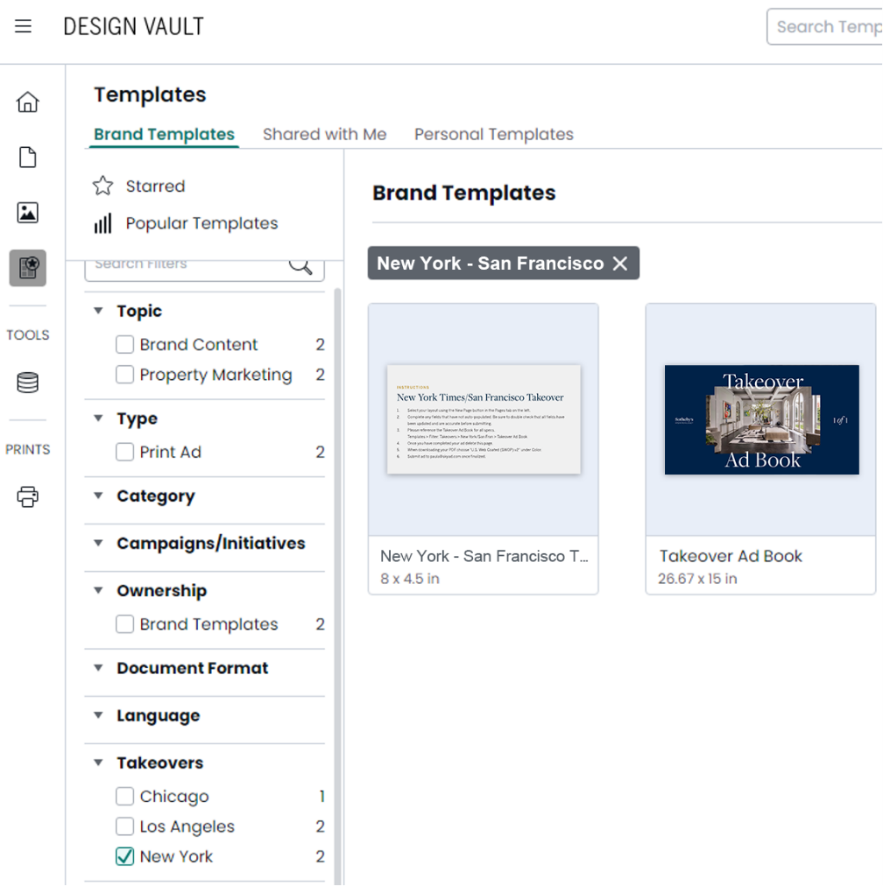
You will find the instructions and the Takeover Ad Book (how to create your ad) within the template page for your reference.

Follow the instructions to create your ad.
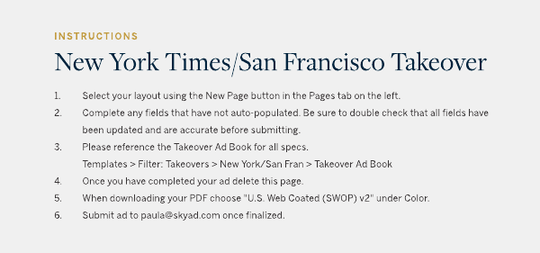
Submit your ad:
Once you have completed your ad in Design Vault, submit the link to Sky by doing the following:
1. Choose the “collaborate” button top right 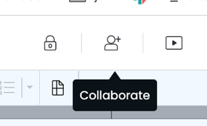
2. Click “shareable link”
3. Click Generate button
4. Once complete, submit your materials here: The New York Times Takeover or The San Francisco Takeover
Scroll down two-thirds of the page to: Submit your Camera-Ready Ad Link Created in Design Vault Ad
If you do not have payment information on file with Sky, payment can be made through our payment portal: https://payment.skyad.com/

